ASIA PACIFIC INSTITUTE OF INFORMATION TECHNOLOGY
Level 4

COMP40004 WEB DEVELOPMENT AND OPERATING SYSTEMS

Individual Assignment 2 (Weightage 30%)

You are required to design and implement a simple web application which demonstrates the usage of proper web standards.

Learning Outcomes

Upon completion of this assignment, you will be expected to achieve the following learning outcomes:
- DESIGN, PROGRAM AND TEST A WEB APPLICATION USING CURRENT WEB STANDARDS, AND IN DOING SO, ADDRESS THE TARGET AUDIENCE AND DEVICE IN THE PROCESS SO THAT THIS WORKS EFFECTIVELY FOR MOBILE AND OFFLINE USE

Technical Requirements
The solution needs to be implemented using HTML and CSS with NO external web creator tools or any external libraries.

Scenario

You have been asked to create a client-side web application to showcase “Wildlife in Sri Lanka”. The need arose by the government of Sri Lanka to boost tourism. They need to provide tourists with an overall view of Sri Lankan wildlife via the website. You need to show your skills in web development, including web design, creating pages with HTML, styling using CSS and testing web applications.
The application should be designed to showcase you and your skills, suitable to market yourself later to prospective employers.
The site map for the application is shown below:
Web Application

Home Page
Sri Lankan wild life introduction
Sri Lankan Leopard
CSS Design 1 for Yala National Park
Animals in Sri Lanka
CSS Design 2 for Wilpattu National Park
Department of Wildlife conservation

Assignment criteria

- Your whole application must:
- The site must be created using PURE HTML and CSS; NO template editors or generator tools can be used.
- NO External CSS and JavaScript libraries can be used apart from what is listed below.
  - Tailwind CSS
  - Alpine.js
  - Swiper.js
- Must have a minimum of 7 HTML pages and are not limited to:
  - Home page
  - Sri Lankan wildlife introduction
  - Department of Wildlife Conservation
  - Sri Lankan Leopard
  - Animals in Sri Lanka
  - Yala National Park
  - Wilpattu National Park

- Your whole application must be a progressive web application and, therefore, must:
- Be hosted on HTTPS (GitHub Pages)
- Contain a web manifest with icon files
- Contains responsive images for different screen resolutions

- Your whole web application should be styled using ONLY CSS, ensuring that it:
- Suits for the target audience
- It is responsive on all pages from mobile devices to desktop devices
- No inline STYLES; all CSS should be in its own CSS files linked using the link tag
- Works on all modern browsers
- Shows the appropriate number of columns on mobile and desktop
- Shows responsive tables
- Shows how animation can help the user experience by providing items the user can interact with
- Shows your skills in DRY standards conformant CSS
- Each page must contain suitable and appropriate HTML for the following:
- Semantic HTML
- <header>, <main>, <footer> tags
- A navigation section with <nav> tags and appropriate links
- References of content as comments in the footer area
- Semantic tags for elements, sectioning, grouping, text and media

- The Home page must contain the following:
- An introduction to Sri Lankan wildlife
- A suitable responsive main image
- Three sub-sections, each having
  - A suitable image
  - At least two paragraphs of applicable content
  - Appropriate headings
- All the following items are somewhere on the page
  - A bullet point list of relevant content
  - A numbered list of relevant content
  - HTML comments for use by developers, which are not displayed on the page

- The Sri Lankan wildlife introduction page must contain the following:
- Suitable content about different wildlife locations (other than Yala and Wilpattu) in the country (each area needs to have a name, a map, images and a description)
- A summary table showing suitable content about specific types of wildlife we can find in the locations you mentioned above:
  - You can select which data to present here, e.g., animal name, interesting facts about the animal, image, etc.
- The table must have (you can decide on the appropriate content for the table)
  - appropriate headings
  - at least three columns and at least three rows
  - a table footer

- The Department of Wildlife Conservation page will contain the following:
- Brief introduction about the department
- A galley using a flexbox to showcase protected areas
- Google location/ map of the department

- The Sri Lankan Leopard page will contain the following:
- Descriptions of at least three venues where Leopard is found in Sri Lanka
- Two sections (one for each threat to leopards), having:
  - An appropriate image
  - A brief description of the threat, its consequences and what mechanisms are taken to reduce the threat
  - An appropriate link to a suitable leopard conservation institution in Sri Lanka

- Animals in Sri Lanka
- This page should provide a brief about indigenous animals in Sri Lanka.
- The page should have links to Yala National Park and Wilpattu National Park pages.

- Yala National Park and Wilpattu National Park pages
- These two pages must have identical HTML.
- The HTML pages must have at least the following
  - A main image
  - At least one other image
  - At least three sections
  - A header and a footer
  - A navigation section with appropriate links
- Each page must link to a separate CSS file.
- Each page must be styled differently to demonstrate that the same HTML can appear differently depending on the CSS.
- Each page must have at least one animation.

Tasks

You will need to submit the following
A PDF document which consists of your wireframes and project brief
A link to your web application and your project folder
- Design your web application showing low-fidelity wireframes for all your pages in a desktop and mobile layout
- Build your web application as per the specifications shown above
- Create a Word document report and convert it to PDF, which offers the following
- A description states what you learned from this project, any challenges you faced, and how you overcame them.
  - Your wireframes for both desktop and mobile versions

Marking Criteria – Assignment 2
Task | Marks
Report/Application - Design  - Suitable wireframes for both Desktop and mobile versions | 10
Application  - your conformance to the specification requirements 4-9  - Your implementation of good-quality code | 10
Application – Progressive Web Application  - your conformance to the specification requirements 1-2  - your implementation of good quality, well-structured code | 10
Application – Site CSS  - your conformance to the specification requirements 3  - your implementation of good quality code  - your UI / UX skills for usability and design | 10
Application – CSS Skills  - your conformance to the specification requirement 10  - your implementation of good quality code  - your management of CSS files and usage of classes | 15
Application - Overall discretionary mark  - your use of innovative approaches to the problem  - your demonstration of high-level coding skills  - robustness of the final web application  - your use of Semantic web technologies for SEO support | 20
Application demonstration and Q/A | 25
TOTAL | 100
Note: 30% is taken from the total as the final mark
COMP40004 WEB DEVELOPMENT AND OPERATING SYSTEMS

Individual Assignment 3 (Weightage 30%)

Assignment criteria

- Implement JSON data objects to convert your HTML pages. (Apline.js stores)
  - You must have JSON files for all HTML pages
  - At least 60% of the website content must be converted to a data object/s (Apline.js stores), and the hard-coded content must be loaded dynamically.
  - The JSON data MUST be stored in the browser window.localStorage.
- Implement a user login.
  - Create a JSON with the following syntax. And store it in a (Alpine.js store)
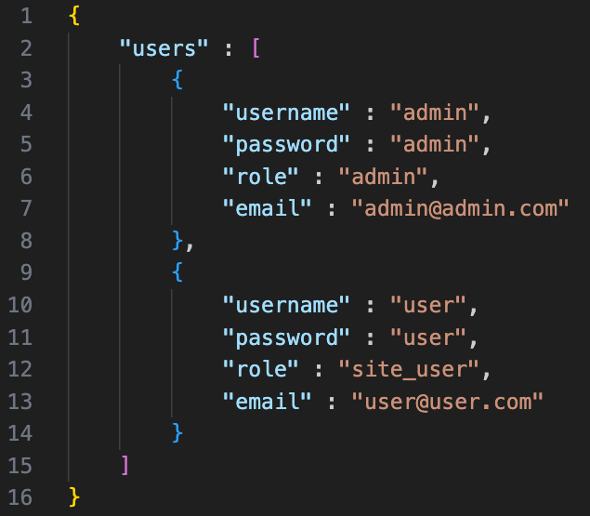
  - Create a login HTML page with the option to log in with the username and password.
  - When successfully authenticated, the user must be sent to the dashboard.
- Edit HTML Content
  - Once the user is authenticated, the user must have an option on all HTML pages to edit the content.
  - The Content Editor must be a popup with the option to edit all the dynamic elements on the HTML page. (Refer point 1)

- Newsletter Subscription
  - The website should have a newsletter subscription in the Footer, and the subscriptions must be saved in the localStorage (Alpine.js Store)
  - Logged-in Admin users should be able to view all newsletter subscriptions.

Marking Criteria – Assignment 3
Task | Marks
Report/Application - Design  - Create suitable JSON data models for all content in the website | 15
Application – User interface  - Implementation of a user login  - Implementation of a popup content editor  - Implementation of a newsletter registration | 20
Application –Web Application  - Admin users should be able to log into the system  - Site authentication must be managed using localStorage  - All dynamic content must be editable (images can be skipped)  - List of newsletter subscriptions must be visible for the admin users | 20
Application - Overall discretionary mark  - Your use of innovative approaches to the problem  - Your demonstration of high-level coding skills  - robustness of the final web application | 20
Application demonstration and Q/A | 25
TOTAL | 100
Note: 30% is taken from the total as the final mark

